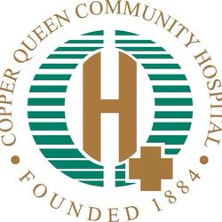
COPPER QUEEN COMMUNITY HOSPITAL
FINANCIAL ASSISTANCE PROGRAM

DATE:
Documentation Required:
- ✔ Verification of Identity (Driver’s license, photo ID with home address, or utility bill)
- ✔ Income (Prior year tax return, three most recent pay stubs, or other)
Patient’s Name: |  | Date of Birth:
Primary Phone #: | Primary Language: | - Male  - Female
Home Address:  Street address 1: | Mailing Address:  Street address 1: | Annual Household Income:
Street address 2: | Street address 2: | Number of Household Dependents:  (Including self)
City: | City: | Email Address:
State: ZIP: | State: ZIP:
I understand that if my income is over 200% of the Federal Poverty Level, I may not qualify for this program. Therefore, I will be responsible for 20% of the full charges if am uninsured or the full patient responsibility amount if I am insured. I also verify that all the above information is true to the best for my knowledge, and I agree to immediately notify the staff at Copper Queen Community Hospital if there is any change in the information above.

I also understand this application does not cover charges billed to me from third party organizations to include but not limited to (pathology charges, radiology professional charges, etc.)

I certify that the household size and income information shown above is correct. I understand that information verifying income and household size may be required.
I understand that future eligibility may be based on application for participation in current federal/state public assistance programs.

Patient/Guardian Signature Date Staff Witness Signature Date

FOR INTERNAL USE ONLY
List all MRN’s in household:
Notes:
MM/DD/YYYY
MM/DD/YYYY
Reviewed by: Date:
Approved by: Date: Charity approval timeframe: / / through / /
- Dis-Approved
To be completed by the Business Office ☐ Approved
Are all required documents included? ☐ Yes ☐ No Is the patient over 200% FPL? ☐ Yes ☐ No
Initial amount to be adjusted? $
Rev 11/15/2023 NO

