Kara L. Gordon, D.P.M., M.B.A.
Douglas RHC
100 E. 5th St. Douglas, AZ 85607
Phone: 520-805-6800
Fax: 520-364-8541

Palominas RHC
10524 E. Hwy 92, Palominas, AZ 85615
Phone: 520-366-0300
Fax: 520-366-9841

Patient Name: _____________________________________________ DOB:________________________
Home Phone Number:_______________________ Alternative Number:________________________

May our office staff leave a message on your voicemail regarding appointments, billing questions, or prescription information? ☐ YES ☐ NO

Please list the names of any individuals that our office staff has permission , which is given by you, to speak with:
Name: ________________________ Relationship: ________________________ Number: ___________________
Name: ________________________ Relationship: ________________________ Number: ___________________

Responsible Party PRINT: ______________________________________________________________
Responsible Party SIGNATURE: ________________________________________________________
Date: ___________________________________

MEDICATION CONSENT
Our system can pull your prescribed medications directly from your pharmacy when available. Please sign below giving us your consent.

Patient Guardian Signature: _____________________________________________________________

Kara L. Gordon, D.P.M., M.B.A.
Douglas RHC
100 E. 5th St. Douglas, AZ 85607
Phone: 520-805-6800
Fax: 520-364-8541

Palominas RHC
10524 E. Hwy 92, Palominas, AZ 85615
Phone: 520-366-0300
Fax: 520-366-9841

Patient Name: ___________________________________________ DOB: ___________________ Date: __________________
Primary Care Provider: _____________________________________ Pharmacy: ____________________________________
Shoe Size: ______________ Height: ________________ Weight: ________________
Allergies: ☐No Know Allergies ☐Penicillin ☐Morphine ☐Tape_____________ ☐Sulfa Drugs ☐Aspirin ☐Codeine ☐Other_________________________________

Medical History: Please indicate if you currently have or have ever had any of the following.
☐None | ☐Diabetes Type 1 | ☐Hepatitis or Jaundice | ☐Osteoarthritis
☐Acid Reflux | ☐Diabetes Type 2 | ☐High Blood Pressure | ☐Vascular Disease
☐Anemia | ☐Diabetes Neuropathy | ☐High Cholesterol | ☐Respiratory Problems
☐Arthritis | ☐Dialysis | ☐HIV | ☐Rheumatoid Arthritis
☐Asthma | ☐Epilepsy | ☐Kidney Disease | ☐Sickle Cell Disease
☐Back Problems | ☐Fibromyalgia | ☐Kidney Stones | ☐Stroke
☐Bleeding Disorder | ☐Gastric Ulcers | ☐Leg or Foot Ulcer/Sores | ☐Thyroid Disease
☐Bone/Muscle Problem | ☐Gout | ☐Liver Disease | ☐Tuberculosis
☐Cancer | ☐Head/Brain Injury | ☐Low Blood Pressure | ☐Varicose Veins
☐Circulatory Problems | ☐Hearing Impaired | ☐Lupus | ☐Venereal Disease
☐COPD | ☐Hemophilia | ☐Mental Health Problems | ☐Other:
☐Currently Pregnant | ☐Heart Disease | ☐Multiple Sclerosis

Past Surgeries: ☐ None ☐ See Attached Social History
_________________________________________ Occupation:______________________________________
_________________________________________ Tabacco use: ☐Never ☐Past ☐Current-How much?
_________________________________________ Alcohol Use: ☐Never ☐Past ☐Current-How much?
_________________________________________ Illicit Drug Use: ☐Never ☐Past ☐Current-What?
Family History(If any family history, please not WHO nest to the condition.)
☐ No Medical Problems | Diabetes | Leg or Foot Ulcers
☐ Don’t Know | Gout | Liver Problems
Arthritis | Heart Disease | Respiratory Problems
Cancer | High Blood Pressure | Stroke
Circulatory Problem | Kidney Problem | Sickle Cell Disease

Current Medications: ☐None ☐See Attached
____________________________________________________________________________________________________________________________________________________________________________________________________________________________________________________________________________________________________________________________________
Kara L. Gordon, D.P.M., M.B.A.
Douglas RHC
100 E. 5th St. Douglas, AZ 85607
Phone: 520-805-6800
Fax: 520-364-8541

Palominas RHC
10524 E. Hwy 92, Palominas, AZ 85615
Phone: 520-366-0300
Fax: 520-366-9841

Patient Name: ________________________________ DOB: ____________________ Date: __________________

Review of Symptoms: Please check items that currently apply to you.
General  ☐Fatigue  ☐Fever  ☐Night sweats  ☐Recent weight changes  ☐Other | Cardiovascular  ☐Chest Pains  ☐Circulatory Problems  ☐Heart attack  ☐Heart Problems  ☐Rapid Heartbeat  ☐Fatigue/Weakness  ☐Varicose Veins  ☐Other | Ear,Nose,and Throat  ☐Breathing Difficulty  ☐Ear Discharge  ☐Ear pain  ☐Hearing issues  ☐Hoarseness  ☐Nose Bleeding  ☐Nose discharge  ☐Nose Obstruction  ☐Nose Pain  ☐Sore Gums  ☐Sore Throat  ☐Other | Respiratory  ☐Coughing Blood  ☐Coughing Phlegm  ☐Difficulty Breathing  ☐Lung Problems  ☐Persistent Cough  ☐Shortness of Breath  ☐Wheezing  ☐Other
Eyes  ☐Eye Strain  ☐Eye Pain  ☐Vision Problems  ☐Other | Gastrointestinal  ☐Abdominal pain  ☐Belching  ☐Black/Bloody Stool  ☐Difficulty swallowing  ☐Gas/Bloated  ☐Hemorrhoids  ☐Indigestion  ☐Poor Appetite  ☐Vomiting  ☐Other | Genitourinary  ☐Bladder Trouble  ☐Blood in Urine  ☐Difficulty Urinating  ☐Discolored Urine  ☐Excessive Urination  ☐Frequency of Urination  ☐Painful Urination  ☐Prostate Problems  ☐Other | Skin  ☐Abrasions  ☐Bruises  ☐Rash  ☐Hives  ☐Sores/Ulcers  ☐Itching  ☐Other
Endocrine  ☐Excessive Thirst  ☐Excessive Hunger | Musculoskeletal  ☐Frequent Sprains  ☐Joint Pain  ☐Muscle Pain  ☐Stiffness | Hematologic  ☐Take Aspirin  ☐Take Coumadin | Psychiatric  ☐Depression  ☐Anxiety

What is your Foot Complaint?____________________________________________________________________
Have you ever had a foot or ankle surgery? ☐ No ☐ Yes: What?__________________________________
Who was your foot doctor?________________________________________________________________________
Responsible Party Signature:__________________________________Name:_____________________________
Relationship to the patient:_______________________________________________________________________

Kara L. Gordon, D.P.M., M.B.A.
Palominas RHC
10524 E. Hwy 92, Palominas, AZ 85615
Phone: 520-366-0300
Fax: 520-366-9841

Douglas RHC
100 E. 5th St. Douglas, AZ 85607
Phone: 520-805-6800
Fax: 520-364-8541

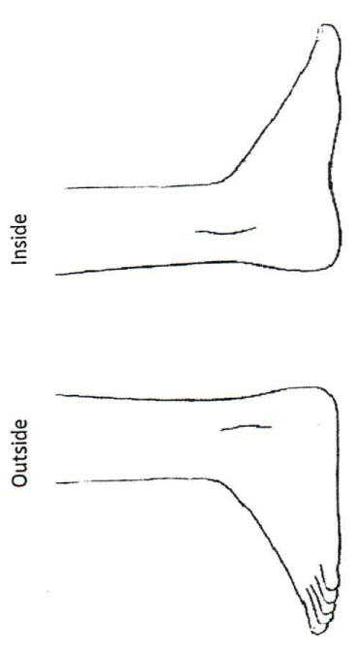
Patient Name: ________________________________ DOB: ____________________ Site: ☐ Right ☐ Left

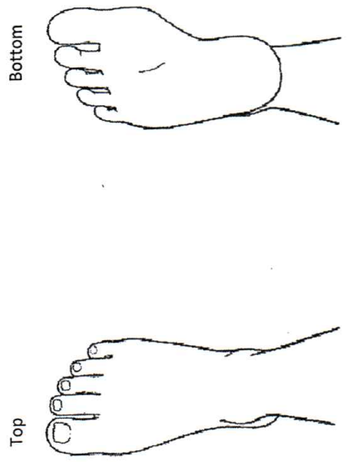
Place “X” where you are having pain:

